|  |  |
| --- | --- |
| TEAM ID | PNT2022TMID22828 |
| PROJECT TITLE | SMART FARMER-IOT ENABLED SMART FARMING  APPLICATION |
| NAME | NITHEEN V P |

ASSIGNMENT – 4

Write a code and connections in wokwi for ultrasonic sensor. Whenever distance is less than 100 cm send an alert to IBM Cloud and display in device recent events.

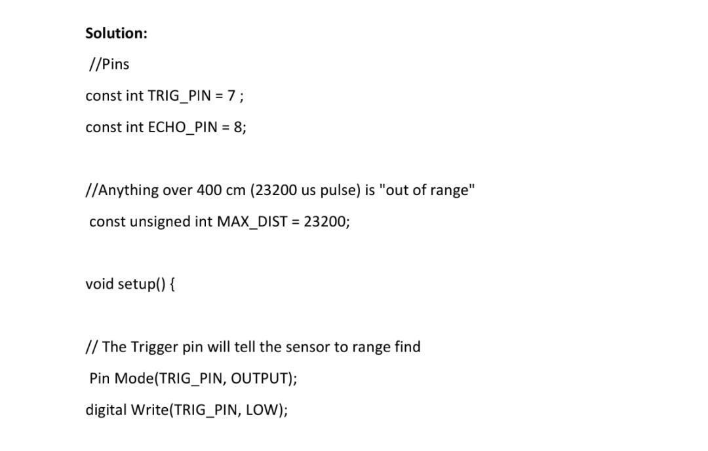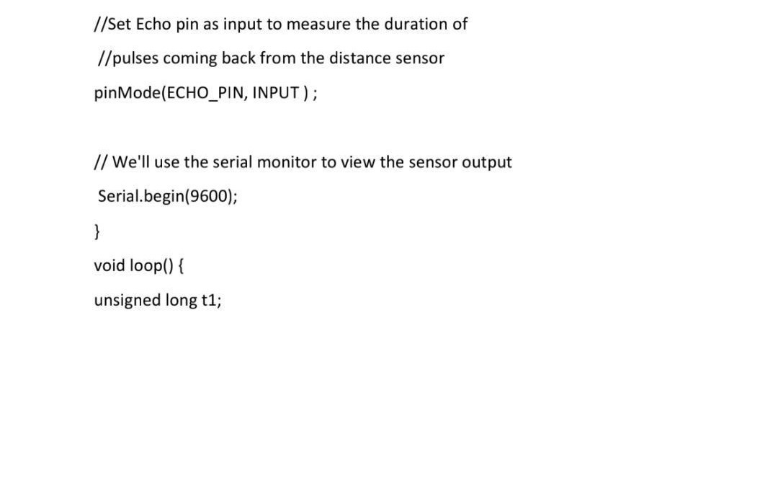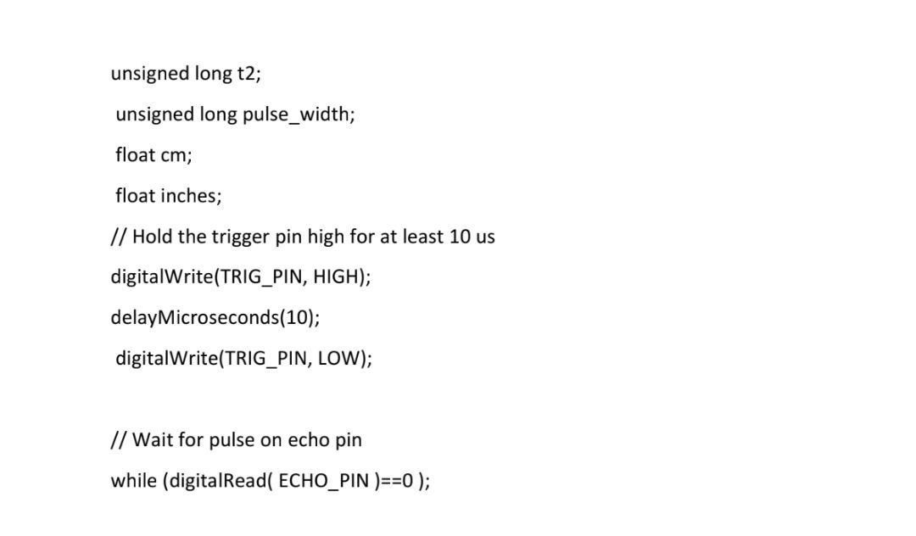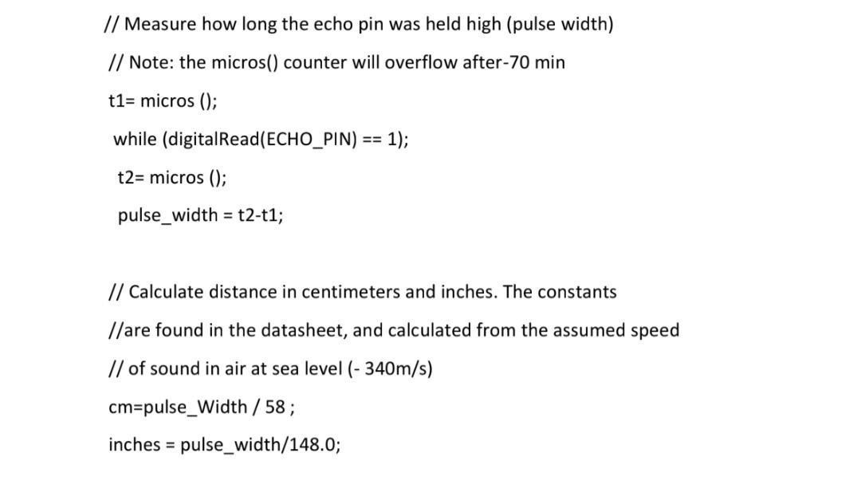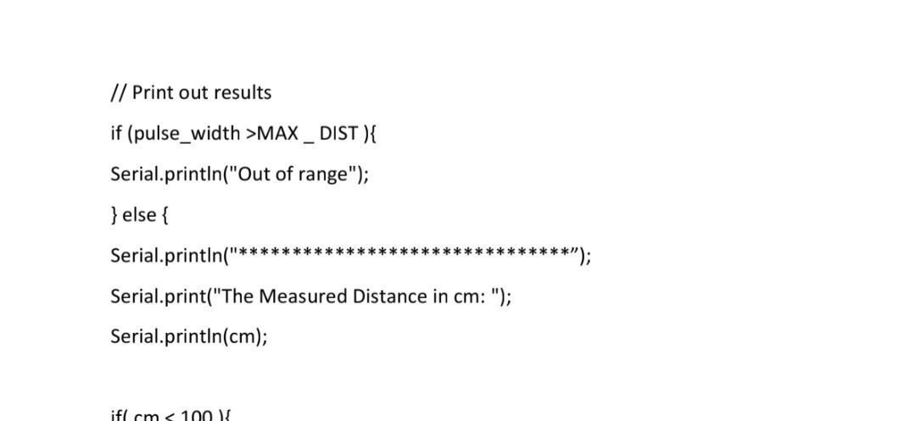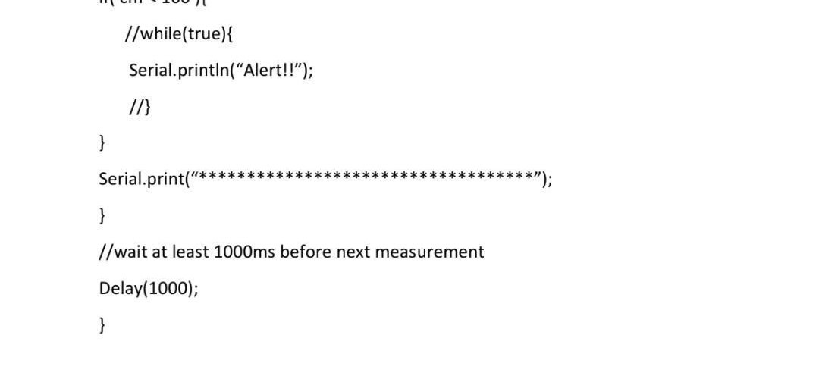

OUTPUT:

